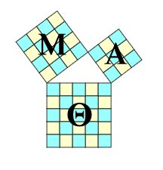Mu Alpha Theta Application
You must have a 3.5 GPA in Math from the previous 2 years and an all-around unweighted GPA of 3.0.
With this form, turn in a print-out (from your student portal) of your course history.
Please turn in to Ms.Lemes in room 288.

Name:___________________________________________
ID: ___________________________________________
Grade: ______________
Unweighted GPA:________

Previous Math Classes and Grades:
1. ___________________________________________
2. ___________________________________________
3. ___________________________________________

Math Class currently enrolled: ___________________________________________

2 Teacher Recommendations
- Name-__________________________________
Subject- ________________________________
Signature-_______________________________

- Name-__________________________________
Subject-_________________________________
Signature-_______________________________

